# Configurable Ground Materials

Changing or adding new ground materials physics, particles, damps, sounds, etc in **Tools 🡪 BoneCracker Games 🡪 Realistic Car Controller 🡪 Configure Ground Materials**.

metin, ekran görüntüsü, yol, mavi içeren bir resim

Açıklama otomatik olarak oluşturuldu

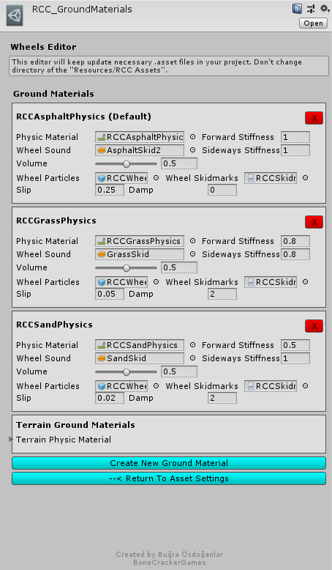

If WheelCollider hits a collider with one of the physic material in list, changes will be applied to the WheelCollider. You can check out demo scenes. Currently three surfaces available such as Asphalt(Default), Grass, and Sand. You will find “**RCCAsphaltPhysics**”, “**RCCGrassPhysics**” and “**RCCSandPhysics**” Physic Materials in the “**Resources**” folder. If your scene ground is not a Unity Terrain, and made by individual gameobjects, you have to assign each ground gameobject collider’s Physic Material to corresponding one. For ex. Select your grass ground gameobject, and select it’s collider’s Physic Material as “**RCCGrassPhysics**”.

# Adjusting Ground Particles, Wheel Sounds, Damp, Forward and Sideway Stiffness, Slip, Skidmarks On Different Grounds

You can adjust ground particles, wheel sounds, damp force, forward and sideway stiffness, slip, and skidmarks of the each ground material here. As i said, these are optional effects. If you don’t want to use them, just leave.

Each material is using unique physic material. If wheel collider of the vehicle hits any of them, corresponding changes will be applied. For ex, wheel collider of the vehicle is on a collider with “**RCCGrassPhysics**”. Forward and sideways slip of the wheelcollider will be adjusted to 0.8, particle of the wheel will be changed, skidmarks of the wheel will be changed, audio clip of the skid will be changed, etc…

**Note**: If wheel collider is not hitting any physic materials in the list, the first one will be used as default ground material.

**Damp** = Difficulty in traction (drag force). Can be used to simulate the engine brake too.

**Wheel Particles** = Will be using this particle if slippage of the wheel collider is higher than target slip value. Just enabling/disabling emission of the particle system. All particles are instantiated by **RCC_CarControllerV3** at the awake. No instantiating or destroying any particles at the runtime.

# Terrain Ground Materials

If your scene has a Unity Terrain as a ground, your terrain textures will decide which surface your on. You will be able to configure existing ground materials, remove, or add new ones.

Each wheel was taking all terrain datas in the scene on older versions. Instead of each wheel, only **RCC_SceneManager** is taking all terrains in the scene. And **RCC_WheelCollider** is checking which surface it's on. That means almost four times less process per vehicle. Reading terrain data per frame is too heavy. **RCC_SceneManager** will read all datas of the terrain at awake once. If you are planning to instantiate more terrains at runtime, **RCC_SceneManager** won’t be able to read it. You have to manually do it by calling “**GetAllTerrains()**” method in your script. It’s a coroutine.

Each terrain must have different collider and terrain data. All of your terrain colliders must be selected in Ground Materials (**Tools --> BCG --> RCC --> Configure Ground Materials**)

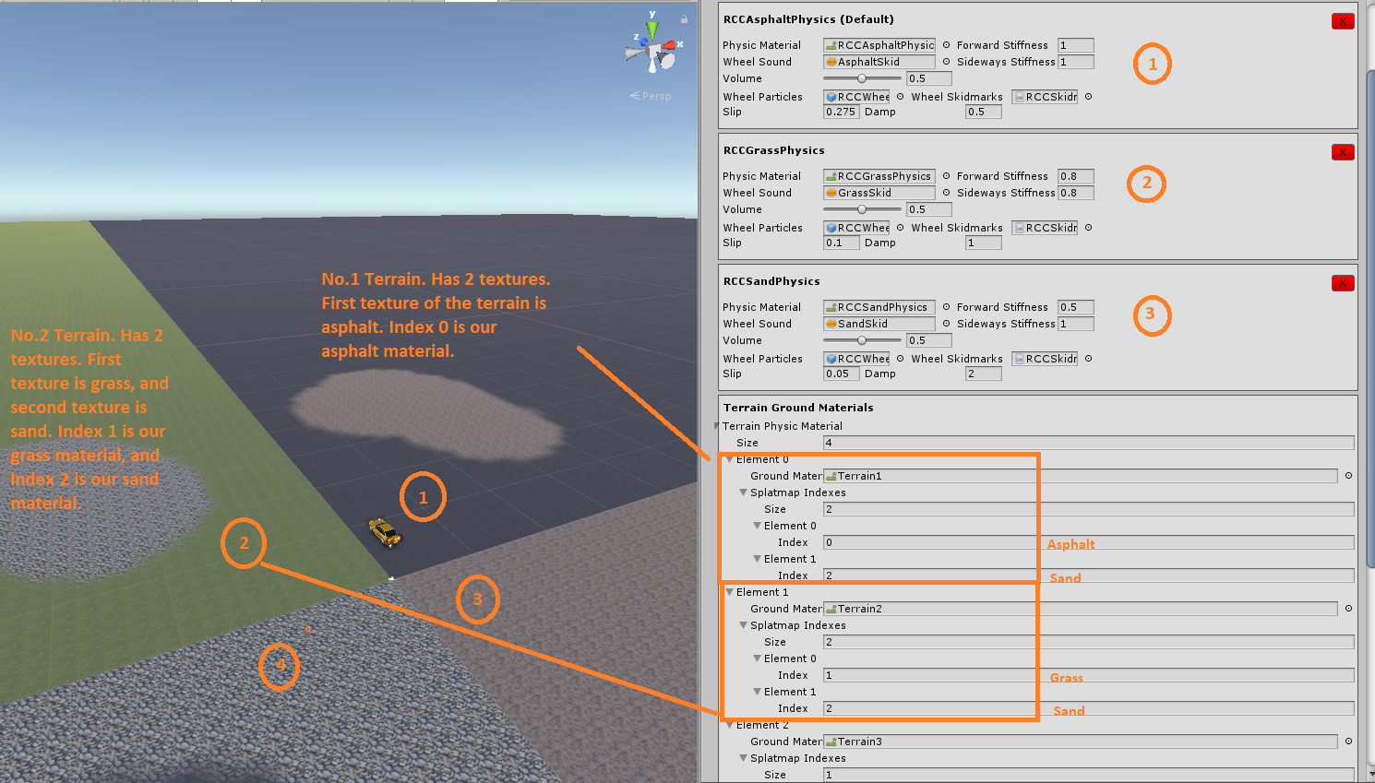

We have three ground materials by default. Asphalt, Grass, and Sand. Their index numbers are 0 (Asphalt), 1 (Grass), 2 (Sand).

Each terrain has multiple splatmap textures. We have to identify which texture represents corresponding material. No matter how much layers your terrains have, the key of the work is identifying them.

Number 1 terrain has two textures. First texture is asphalt, and the second texture is sand. So, we should be setting first index as 0 (Asphalt), and second index as 2 (Sand).

Number 2 terrain has two textures. First texture is grass, and the second texture is sand. So, we should be setting first index as 1 (Grass), and second index as 2 (Sand).

Select each index of your terrain texture slot for corresponding physics material. And yes, supports multiple terrains as well. Just be sure each terrain has unique physic material.

Note: If index is out of range, RCC_WheelCollider.cs will throw many errors and won’t work properly in that case.

# Creating and Adding New Ground Materials

Click “**Create New Ground Material**” button for the new field. Select your own physic material first. You can create new physic materials inside your project by **Right Click 🡪 Create 🡪 Physic Material**. After selecting physic material, you can use your own particle system for ground particles. Select audio clip, and don’t forget to select skidmarks too. RCC has three demo skidmark presets in the project. Asphalt, grass, and sand. You can use one of them, or duplicate one of them and assign new material with new texture for your new skidmarks.